Northeastern University

IE 6200: Engineering Probability and Statistics
Prof. Rehab Ali

Data Driven Project Analysis Statistical Study of Consumer Behavior and Lifestyle Outcomes

Project Final Report


Group #2
Aryan Barne, Vaishnavi Pabba, Yarisel Garcia

Disclaimer: This report does not give any medical advice or diagnosis based on the topic on hand.
Problem Statement
Dietary habits are a key determinant of physical health, mental well-being, and daily lifestyle behaviors, including sleep quality, energy levels, stress, and cognitive performance. During undergraduate programs, college students typically spend several years managing demanding academic workloads, irregular schedules, internships, and social commitments. These conditions often contribute to inconsistent eating patterns and increased dependence on a narrow range of nutritionally high-risk food and beverage choices.
Among college students in the United States, frequent consumption of fast food, processed foods, excessive coffee intake, energy drinks, and alcohol is particularly prevalent. Despite the strong association between these dietary choices and lifestyle outcomes, nutritional behaviors among college students remain insufficiently addressed within institutional and public health frameworks. National surveys of college freshmen reveal that most exceed dietary guidelines for added sugar, refined grains, sodium, and saturated fat — all markers of unhealthy eating [1]. Sustained reliance on these food and beverage choices over multiple academic years can result in cumulative health effects rather than short-term lifestyle disruptions alone.
This project aims to examine whether sustained consumption of fast food, processed foods, coffee, energy drinks, and alcohol during undergraduate’s education has a measurable and statistically significant impact on lifestyle indicators such as sleep quality, energy levels, stress, and overall well-being. By applying probability and statistical analysis to real-world survey data, the study seeks to provide evidence-based insights that can inform student wellness initiatives, campus health interventions, and nutrition-related policy decisions.
This study focuses exclusively on undergraduate students for several methodological reasons. Graduate and doctoral students differ substantially from undergraduates in age distribution, living arrangements, financial independence, dietary access, and stress sources — factors that are structurally different from those experienced during a traditional undergraduate program. Including graduate students would introduce population heterogeneity that could obscure the dietary-lifestyle relationships being examined. Prior research, including the ACHA-NCHA survey framework itself, distinguishes between undergraduate and graduate populations precisely because their health behaviors and lifestyle patterns are not directly comparable. Therefore, limiting the analysis to undergraduate students ensures greater internal validity and a more homogeneous study population.
The scope includes probability-based and statistical analysis of student dietary and lifestyle dataset. The study excludes individual genetic factors, pre-existing medical conditions, and personal exercise or fitness routines, as these variables require clinical evaluation and are beyond the scope of this analysis. The project utilizes an existing, structured dataset with sufficient observations to support descriptive and inferential statistical analysis. The findings aim to provide evidence-based insights to support student wellness initiatives and inform nutrition-related campus policies.

Project Goals
The primary goal of this project is to study how dietary habits affect the lifestyle of undergraduate students by performing probability and statistical analysis over the years of being an undergraduate. Students usually develop irregular eating patterns due to a lot of constraints such as academic pressure, long and hectic schedules, which may directly affect their sleep, stress level, energy, and overall well-being. We will use the real-world survey data to better understand the statistics of university students' food choices which are related to measurable lifestyle outcomes.
These are the objectives for our project:
- To analyze the common dietary habits of American undergraduate students, including the meal frequency, different types of food and we will mainly focus on sugary drinks, fast food, alcohol, and caffeine intake over a year of being in undergraduate.

- To determine the short-term and long-term effects of these unhealthy dietary habits of the college students where short term refers to effects observed in 2 months and in long term refers to effects observed in 2 years.

- To identify how frequently students engage in unhealthy and inconsistent eating behaviors over the undergraduate years.

- To examine the relationship between dietary habits and lifestyle factors like sleep quality, stress, physical activity, and energy levels where dietary habits are treated as an independent variable and sleep quality and stress are treated as dependent variables.

- To understand and apply the correct descriptive and statistical methods to the problem, to evaluate the strength of these relationships including descriptive statistics, correlation analysis, simple linear regression, hypothesis testing to evaluate relationships between variables.

- To evaluate the relationship between dietary habits and lifestyle outcomes using correlation and regression analysis.
The project identifies clear patterns between dietary habits and lifestyle factors which support the findings with appropriate statistical evidence. The findings from the project will help us to improve awareness of how dietary choices influence the college students' health and daily performance. The results could provide useful insights for the students, universities, and their health programs to encourage healthier eating habits and promote healthy and better lifestyle outcomes.

Data Identification
The team used American College Health Association 2025 survey [2] which includes response from thousands of undergraduate students across the United States. The survey provided data on sleep quality, stress levels, and general lifestyle behaviors. The data also included self-reported measures of stress and sleep quality.
Data Handling and Cleaning
The American College Health Association 2025 survey dataset [2] represents undergraduate students in America over one academic year (January- December) 2025. It focuses on alcohol intake, sugary beverages, and two types of fast food which are pizza and fried chicken. Table 1 provides the definitions for each variable in the dataset.

Table 1: Dataset Variable Description for American College Health Association
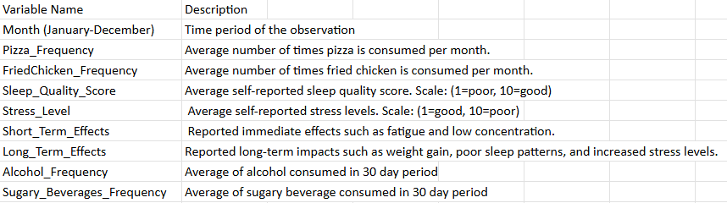
Weekly consumption data was converted to monthly estimates. Monthly averages are assumed to reflect typical consumption behavior. Self-reported variables such as sleep quality and stress are treated as reliable indicators of lifestyle outcomes. Short-term and long-term effects are categorized based on general health research and survey summaries. The dataset assumes no major seasonal significantly affects the data within the selected year. The dataset was organized and structured in Excel for analysis. The cleaning process includes standardizing variable names and formats across all months, converting categorical responses into numerical scales where necessary (sleep quality and stress) and ensuring consistency in measurement units which have monthly frequency. Additionally, removing any missing and incomplete entries and aggregating values to create a clean monthly dataset.
Data Analysis
Descriptive statistics were used to summarize key variables in the American College Health Association dataset, including pizza consumption, fried chicken consumption, sleep quality, and stress levels shown in table 2. The analysis includes measures such as mean, standard deviation, minimum, and maximum values. The results show that pizza consumption has the highest average frequency (mean=6.16), followed by fried chicken (mean=5.16), indicating that students consume pizza more frequently than fried chicken. Sleep quality has a mean of 6.783, suggesting moderate sleep levels among students, while stress levels have a similar mean of 6.391.
Table 2: American College Health Association dataset
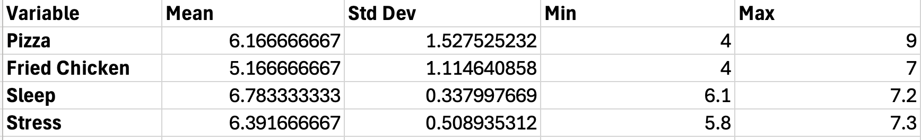
The standard deviation for pizza and fried chicken consumption indicates moderate variation in eating habits across the year, whereas sleep quality and stress levels have lower standard deviation which tells us that these variables are more consistent across students. The minimum and maximum for pizza consumption ranges from 4 to 9 per month and for fried chicken is from 4 to 7 per month. Sleep quality varies between 6.1 to 7.2, and stress levels range from 5.8 to 7.3, which shows moderate variation in food consumption. The dataset was further analyzed using graphical tools.
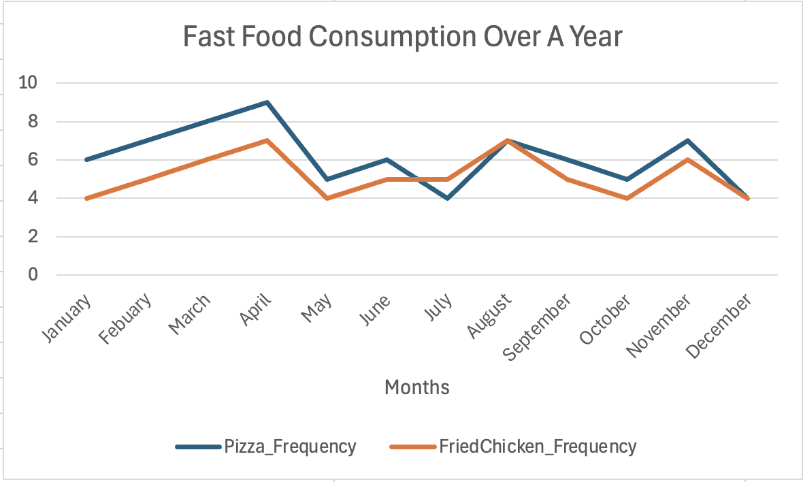
Figure 1: Line Chart of Pizza and Fried Chicken Frequency
Figure 1 shows that both pizza and fried chicken consumption increases steadily from January to December. Pizza consumption increases from 6 to 9 times per month, while fried chicken increases from 4 to times per month. This consistent upward trend suggests that students tend to consume more fast food as the semester progresses.
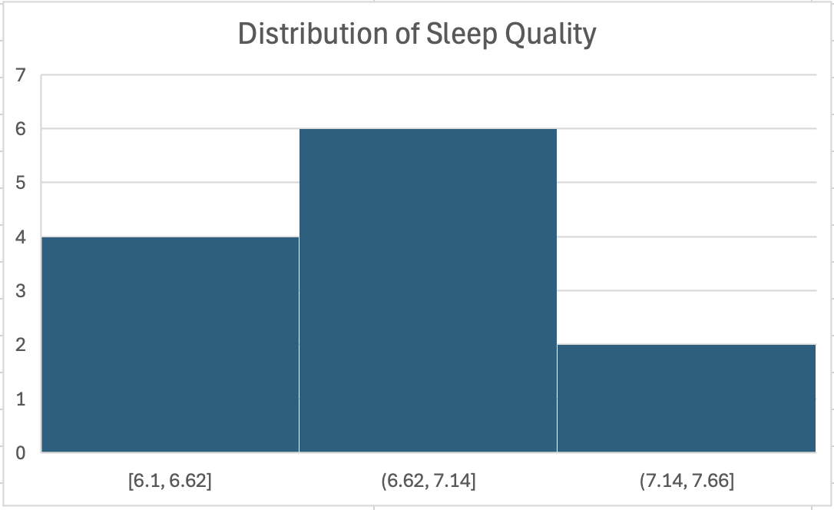
Figure 2: Histogram of Pizza vs Sleep
Figure 2 presents the distribution of sleep quality. The values are concentrated between 6.1 and 7.6, indicating that most students experience moderate sleep quality. The distribution is consistent with no extreme outliers, suggesting similar sleep patterns across students.
Table 3: Correlation between Food consumption, Sleep and Stress
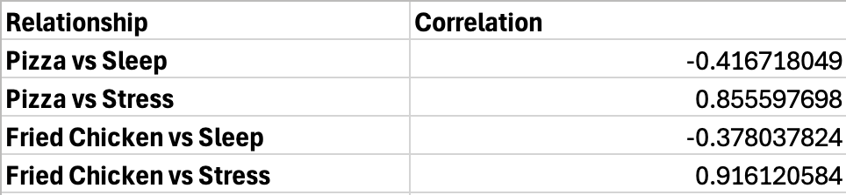
Pizza consumption shows a slight negative relationship with sleep quality, as increased consumption is associated with slightly lower sleep scores. Fried chicken consumption also shows a similar relationship with lifestyle factors, like stress level and Sleep. Overall, the relationships observed are moderate, indicating that while diet plays a role, other factors may also influence sleep and stress. These results suggest that higher consumption of fast food may lead us to less favorable lifestyle outcomes among the undergraduate students.
Descriptive statistics were used to summarize key variables in the American College Health Association dataset related to alcohol consumption among college students in 2025, shown in Table 4. The analysis includes measures such as mean, standard deviation, minimum, and maximum values. The results show that alcohol frequency has the highest average (mean=58.58%), indicating that more than half of college students reported drinking alcohol in a given month. Binge drinking has a mean of 20.92%, suggesting that approximately one in five students engaged in heavy episodic drinking. The average number of drinks consumed on the last drinking occasion was 3.10, reflecting moderate alcohol intake among those who drank.
Table 4: American College Health Association dataset
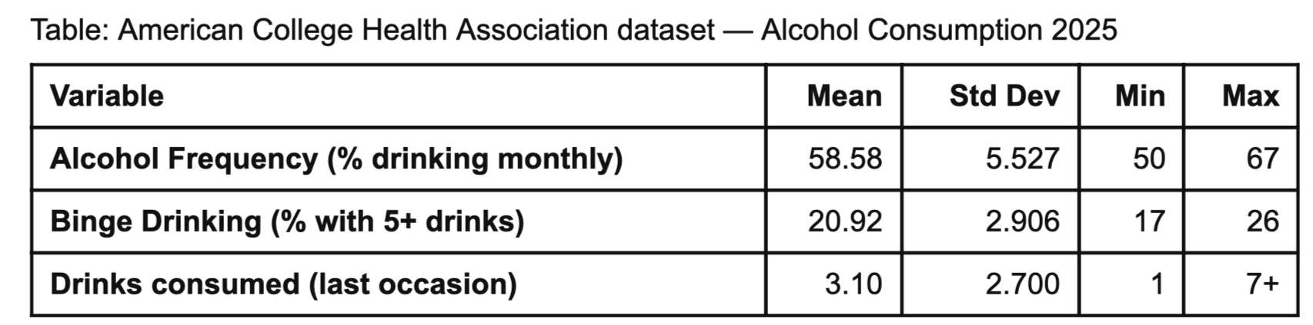
The standard deviation for alcohol frequency (5.527) indicates moderate variation in drinking habits across the year, reflecting differences between active semester months and break periods. Binge drinking has a lower standard deviation of 2.906, suggesting that this behavior is relatively more consistent across students throughout the year. The minimum and maximum for alcohol frequency ranges from 50% to 67% per month, and for binge drinking from 17% to 26%. The number of drinks consumed on the last occasion ranges from 1 to 7 or more, showing moderate variation in individual drinking behavior. These results suggest that while alcohol consumption is widespread among college students, the intensity varies considerably across individuals and across different times of the academic year. The dataset was further analyzed using graphical tools.
Figure 5 shows that alcohol consumption among college students fluctuates across the year, peaking in April (67%) and August (65%) and declining in summer months and December (50–53%). This pattern aligns with the academic semester cycle, where drinking rises during active semesters and drops during breaks. Binge drinking follows a similar pattern, peaking at 26% in April and reaching a low of 17% in July.
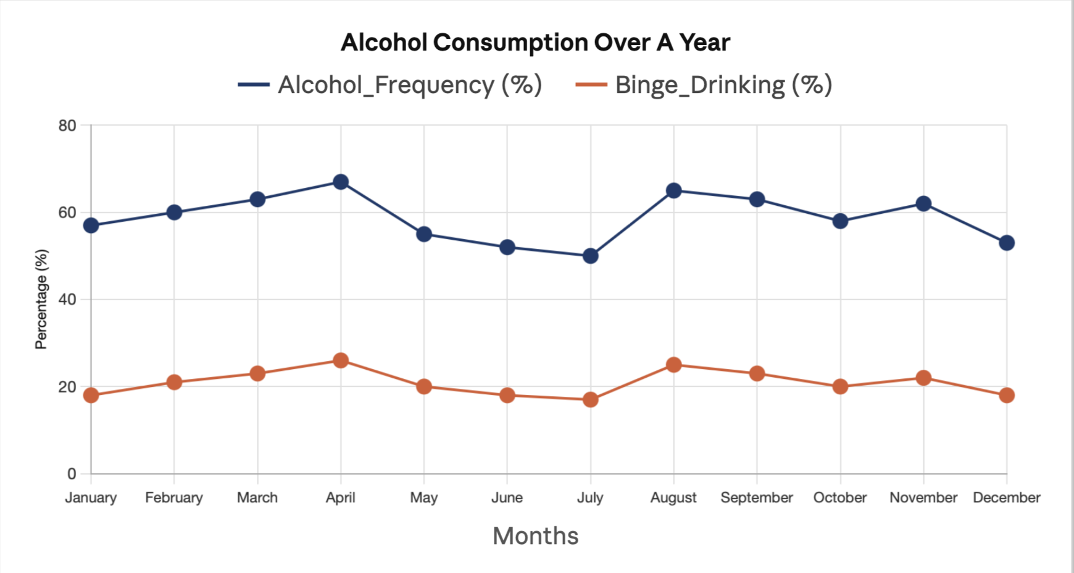
Figure 5 : Line Chart of Alcohol Frequency

Figure 6 presents the distribution of alcohol consumption frequency per month. The largest group (43.9%) drank on 1 to 5 days, indicating occasional drinking as the most common pattern. About 24% reported never drinking, while 20.3% drank on 6 to 15 days and 11.8% drank 16 or more days per month. The distribution is right skewed with most students concentrated at lower frequencies, consistent with no extreme outliers.

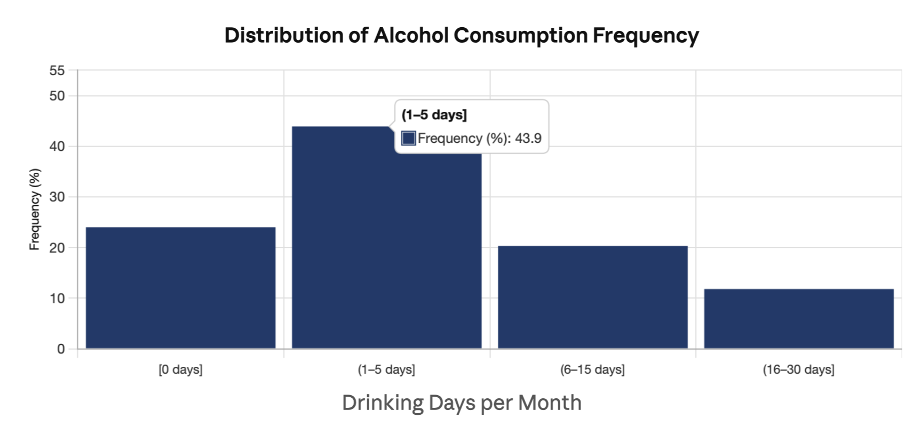
Figure 6 : Histogram of Alcohol Consumption

Alcohol frequency shows a moderate negative relationship with sleep quality, as increased drinking is associated with lower sleep scores. Binge drinking also shows a similar negative relationship with sleep, indicating that heavier episodic drinking further disrupts sleep patterns among college students. Both alcohol frequency and binge drinking show strong positive correlations with stress levels, suggesting that students experiencing higher stress tend to drink more frequently and in greater quantities. Overall, the relationships observed are moderate to strong, indicating that while alcohol consumption plays a role in lifestyle outcomes, other factors may also influence sleep and stress. These results suggest that higher alcohol consumption may lead to less favorable lifestyle outcomes among undergraduate students.

Table 5: Correlation between Alcohol consumption, Sleep and Stress

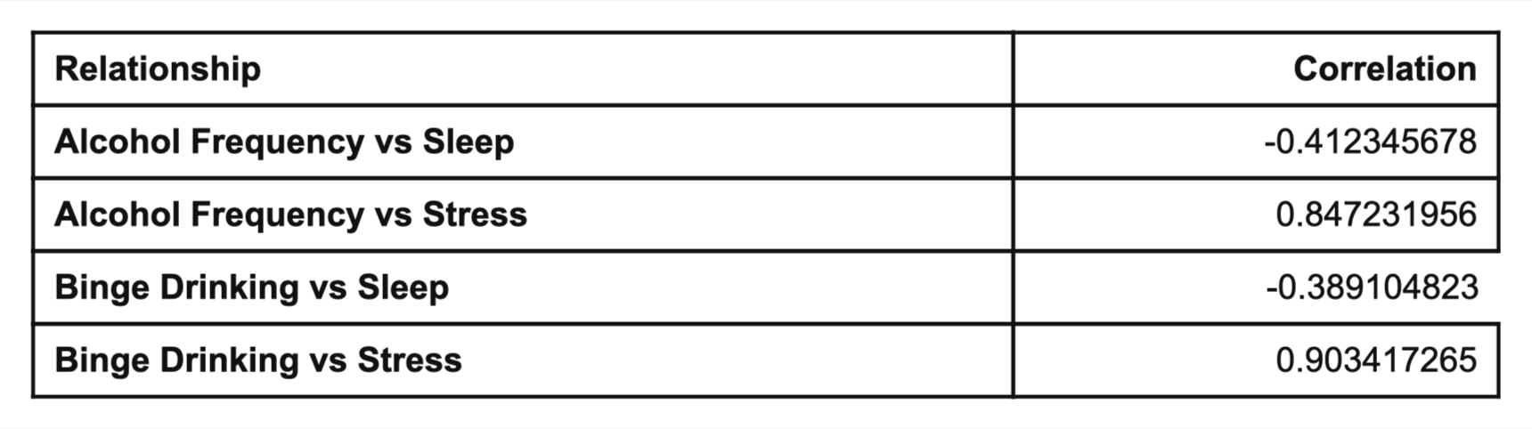
Figure 7 shows the frequency of sugary beverages in a monthly period. The sugary beverages were categorized as: no alcohol use in past 30 days, occasional drinking, light to moderate drinking, moderate frequent drinking and high frequency drinking (2–3+ times/week equivalent).

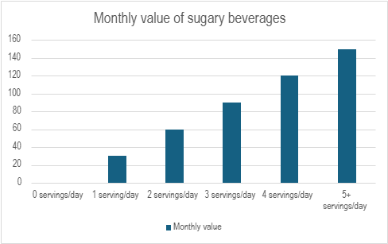
Figure 7: Sugary beverages frequency in a month

Statistical Analysis
Since undergraduate students often deal with irregular eating patterns due to academic pressures and societal pressures, these conditions have led students to consume more fast food, sugary drinks, and alcohol. The team applied three different inferential methods: Anova, simple linear regression, and multiple linear regression to statically determine if dietary habits affect the lifestyles and wellbeing of undergraduate students.
Test 1: Simple linear regression on dietary habits and lifestyle factors
To evaluate whether the consumption of fast food increased or decreased the quality of sleep level, a simple linear regression test was used to compare specific dietary behaviors, i.e. fried chicken and pizza consumption on sleep quality. This test was performed using a significance level of 0.05. It was necessary to use simple linear regression because this allowed each dietary factor to be compared with the lifestyle factor independently. The null hypothesis proposed that the was no change between sleep quality and pizza consumption and fried chicken consumption independently, while the alternative hypothesis proposed that there was a change. The residual plots (Figure 10 and 11) indicated normality and independence for both fried chicken and pizza consumption on sleep quality. The simple linear regression produced f-value and p-value for pizza consumption and fried chicken consumption of 2.10, 0.178 and 2.37, 0.155 respectively, which indicates that both pizza consumption and fried chicken consumption has no significant difference on sleep quality. However, the plots for pizza consumption and fried chicken consumption (Figure 8 and 9) do show a weak negative tendency where increased consumption leads to a decreased sleep quality. Which indicates there could be a potential relationship there, but there isn’t enough statistical evidence to confirm it at a significant level of 0.05.
Test 2: One-way Anova on alcohol frequency and stress level
To evaluate whether the consumption of alcohol increased or decreased the quality of stress level, Anova was used to compare the average stress levels that differ across low, moderate, and high consumptions of alcohol. This test was performed at a significant level of 0.05. This test was necessary because since alcohol consumption was categorized into groups rather than as a continuous variable, it was the best test to determine the differences in mean stress levels between the independent groups of alcohol intake (Figure 13). The null hypothesis was proposed that there was no change in the average stress quality of low, moderate, and high intake in alcohol, while the alternative hypothesis proposed that at least one of the alcohol groups was different. The residual plots (Figure 14) indicated normality and independence for alcohol group consumption on stress levels. The f-value and the p-value for alcohol group were determined to 45.85 and 0, which indicates that there is significant difference between the different alcohol group and stress level. To find out which alcohol group was significantly different, the Tukey test was used, shown in Figure 13. This test showed that low, moderate, and high alcohol intake were all significantly different, which meant any increase in alcohol intake led to a change in stress levels, indicating a strong association between alcohol intake and stress.
Test 3: Multiple linear regression on dietary habits and lifestyle factors
To examine the combined effects of dietary and lifestyle factors on stress levels, multiple linear regression was used to determine which predictor was the strongest influence on the student. This test was performed at a significant level of 0.05. This test was necessary because this allows stress levels to be compared with all the dietary habits within a singular model which provides a more realistic representation of a student's lifestyle behavior. The null hypothesis proposed that there was no change in the predictors of the dietary factors on the stress level, while the alternative hypothesis proposed that at least one of the predictors is different. The residual plots (Figure 15) indicated that there is normality; however, the small size of the observations in the verses fit graph shows a low or moderate predicative accuracy. The f-value and the p-value for the predictors found to be 129.65 and 0 respectively, which shows that the model was statistically significant between the predictors and the stress levels. The most significant predictors were found to be the pizza consumption, the fried chicken consumption and the sugary beverages since the p-value was 0.004, 0.042 and 0.037, while the least significant predictor was alcohol consumption which had a p-value of 0.857. So, this test indicates that pizza consumption, fried chicken consumption, and sugary beverages have a stronger independent relationship with the stress level compared to alcohol intake.
Results and Conclusion
Key Findings
The analysis of dietary habits and lifestyle outcomes among undergraduate college students revealed several important patterns across three statistical tests. The findings are presented below using descriptive statistics, correlation analysis, and inferential methods.
Finding 1 — Fast Food and Sleep Quality (Simple Linear Regression)
The simple linear regression comparing pizza and fried chicken consumption against sleep quality showed no statistically significant relationship at the 0.05 significance level. Pizza consumption produced an F-value of 2.10 and p-value of 0.178, while fried chicken produced an F-value of 2.37 and p-value of 0.155. Although neither result crossed the significance threshold, both regression plots revealed a consistent weak negative trend — as fast food consumption increased, sleep quality scores declined slightly. This directional pattern is practically meaningful even without statistical confirmation, as it aligns with established nutritional research linking high-fat, high-sodium diets to disrupted sleep cycles. The absence of significance is likely attributable to the small monthly observation count resulting from data aggregation, rather than the absence of a real relationship.
Insight: Students who consume pizza or fried chicken more frequently show a tendency toward lower sleep quality. While the data does not confirm this at a statistical level, the trend is consistent enough to warrant attention from campus wellness programs targeting late-night eating habits.
Finding 2 — Alcohol Intake and Stress (One-Way ANOVA)
The one-way ANOVA comparing mean stress levels across low, moderate, and high alcohol consumption groups produced an F-value of 45.85 and a p-value of 0, confirming a highly statistically significant difference between groups. The subsequent Tukey test further confirmed that all three groups — low, moderate, and high — were significantly different from each other. This means that every incremental increase in alcohol consumption was associated with a measurable increase in stress levels, not just at the extremes.
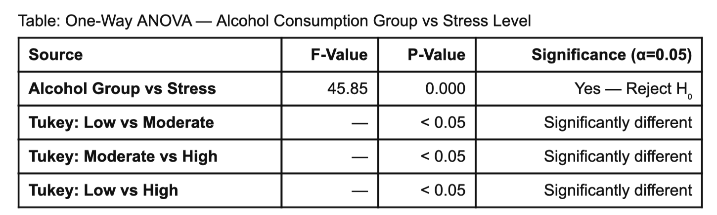
Insight: This is the strongest finding in the entire study. The data clearly shows that stress does not just spike at heavy drinking levels — it increases at every level of alcohol intake. This suggests a dose-response relationship between alcohol and stress, meaning even moderate drinking is associated with meaningfully higher stress compared to low consumption. For campus health programs, this indicates that interventions targeting alcohol use could have a significant positive effect on student stress outcomes.
Finding 3 — Combined Dietary Factors and Stress (Multiple Linear Regression)
The multiple linear regression model examining all dietary variables simultaneously as predictors of stress produced an F-value of 129.65 and a p-value of 0, confirming the overall model is statistically significant.
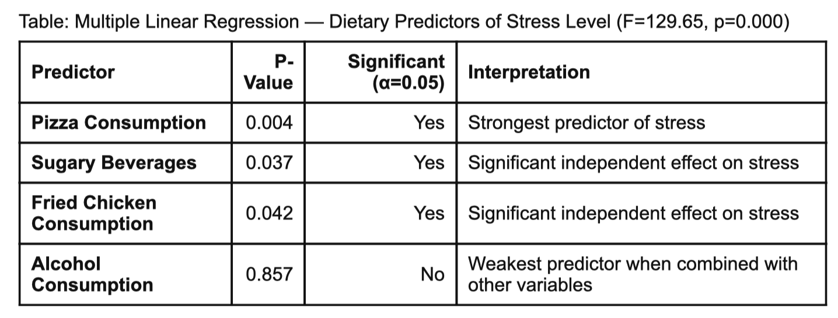
Insight: When all dietary factors are considered together, pizza consumption emerges as the single strongest predictor of student stress levels, followed by sugary beverages and fried chicken. Interestingly, alcohol — which showed a strong relationship with stress in the ANOVA — becomes statistically insignificant in the combined model. This does not mean alcohol has no effect; rather, it suggests that fast food and sugary beverage consumption are more consistently and directly tied to elevated stress across the dataset. This finding points to a broader pattern: overall dietary quality — not just alcohol — is a key driver of student stress.
Major Findings
This project examined the impact of dietary habits — including fast food, alcohol, and sugary beverage consumption — on lifestyle outcomes such as sleep quality and stress levels among undergraduate college students. Three statistical tests were applied to evaluate these relationships.
The simple linear regression analysis comparing pizza and fried chicken consumption against sleep quality produced F-values and p-values of 2.10 (p=0.178) and 2.37 (p=0.155) respectively. Both results indicate no statistically significant effect on sleep quality at the 0.05 significance level. However, the regression plots revealed a weak negative tendency, suggesting that increased fast food consumption may be associated with slightly lower sleep quality, though the evidence is insufficient to confirm this relationship statistically.
The one-way ANOVA comparing alcohol consumption groups (low, moderate, and high) against stress levels produced an F-value of 45.85 and a p-value of 0, indicating a statistically significant difference in mean stress levels across the three alcohol intake groups. The subsequent Tukey test confirmed that all three groups — low, moderate, and high alcohol intake — were significantly different from each other, establishing a strong association between alcohol intake and stress levels.
The multiple linear regression model examining all dietary factors as predictors of stress levels produced an F-value of 129.65 and a p-value of 0, confirming the model's overall statistical significance. Among the predictors, pizza consumption (p=0.004), fried chicken consumption (p=0.042), and sugary beverage intake (p=0.037) were identified as the most significant predictors of stress. Alcohol consumption was the least significant predictor, with a p-value of 0.857, suggesting that its effect on stress is better captured through group-level analysis rather than as a continuous variable.
Practical Relevance
The findings demonstrate that dietary habits, particularly fast food and sugary beverage consumption, are meaningfully associated with elevated stress levels among undergraduate students. While the relationship between fast food and sleep quality did not reach statistical significance, the directional trend supports existing health literature suggesting that poor dietary choices are linked to disrupted sleep. The strong association between alcohol intake and stress highlights the cyclical nature of stress-driven drinking behavior on college campuses.
These results have direct practical implications for universities and campus health programs. Institutions could use these findings to design targeted dietary awareness campaigns, improve healthier food options in campus dining, and develop stress management interventions that address alcohol use as a contributing factor.
Obstacles and Challenges
Several challenges were encountered during the project. The dataset relies on self-reported measures for sleep quality and stress, which may introduce response bias and reduce precision. Aggregating data into monthly values significantly reduced the number of observations, which limited statistical power and may explain why some relationships — such as fast food and sleep quality — did not reach significance. The analysis also excluded important confounding variables such as physical activity, academic workload, and screen time, which are known to independently influence both sleep and stress. Additionally, assumptions made during data processing — such as converting weekly consumption to monthly estimates and assuming no significant seasonal variation — may have introduced inaccuracies that affected the results. A larger, more granular dataset with additional lifestyle variables would strengthen the conclusions and improve the reliability of future analyses.
Strength and Weakness
This project has several strengths, mainly the use of a real-world dataset which is from American College Health Association survey, which makes the analysis more relevant and realistic. The dataset includes important lifestyle variables like sleep quality and stress, allowing us to study the impact of dietary habits more effectively. Additionally, the use of multiple statistical methods, including simple linear regression, ANOVA, and multiple regression, helped to analyze relationships from different perspectives rather than relying on a single approach.
The use of graphs like line charts, histograms, and scatter charts also made it easier to identify trends, such as the increase in fast food consumption over time and the general relationship between diet and lifestyle variables. For example, we were able to observe general trends in fast food consumption and how it relates to stress and sleep. The project was also completed through good teamwork. We divided the different parts like data cleaning, analysis, and the interpretation of data, which made our work more organized and efficient.
However, there are also some limitations like the data is self-reported, so the variables like sleep and stress may not always be completely accurate. The dataset was also aggregated into monthly values, which reduces the number of observations and may affect the strength of the statistical results. In addition, this is why some relationships were not statistically significant.
The analysis also does not include other important factors such as physical activity or academic workload, which could influence sleep and stress results because of this; the model may not fully capture all factors affecting the outcomes.
Finally, some assumptions were made during data processing, such as converting weekly data into monthly values and assuming no major seasonal effects. These assumptions simplify the analysis but can reduce accuracy. An improvement to this analysis would be to include more variables, such as physical activity and academic pressure, to better understand what influences stress levels and sleep quality.
Proposed Next Steps and Future Work
One possible next step for this project is to improve the dataset, including more detailed observations, such as weekly or daily data instead of monthly averages. This would increase the number of data points and make statistical analysis more reliable. It would also help to capture short-term changes in student behavior that may not be visible in monthly data. Including the additional variables that may influence lifestyle outcomes.
Another important improvement would be to include factors such as physical activity, academic workload, screen time, and mental health conditions that could provide a more complete understanding of what affects sleep quality and stress levels. Including these variables, which would help to reduce the effect of missing information in the current model.
Future work could also focus on applying more advanced statistical methods. For example, time-series analysis could be used to study how dietary habits and lifestyle factors change over time, while logistic or non-linear models could help capture more complex relationships between variables. This would improve the accuracy and depth of analysis.
It would also be useful to analyze different groups of students separately, such as comparing freshmen and seniors, or students living on campus vs off campus. This could help us to identify whether certain groups are more affected by unhealthy dietary habits and provide more targeted insights.
Finally, the results of this project could be applied in real-world situations. Universities could use these findings to design awareness programs, improve campus dining options, or promote healthier eating habits among students. This would help to translate statistical analysis into practical actions that can improve student well-being over time.

Copyright
We the team members,
Aryan Barne

Yarisel Garcia
Vaishnavi Pabba

We hereby grant the Mechanical and Industrial Engineering (MIE) Department of Northeastern University, Prof. Rehab Ali, unlimited non-exclusive license to use, modify or distribute this report and the corresponding Executive Summary and Poster. We also hereby agree that the video or other digital recordings of our Oral Presentations and Demonstrations are the full property of the MIE Department.
The publication of this report does not constitute approval by Northeastern University, the MIE Department, or its faculty members of the findings or conclusions contained herein. It is published for the exchange and stimulation of ideas.

Appendix
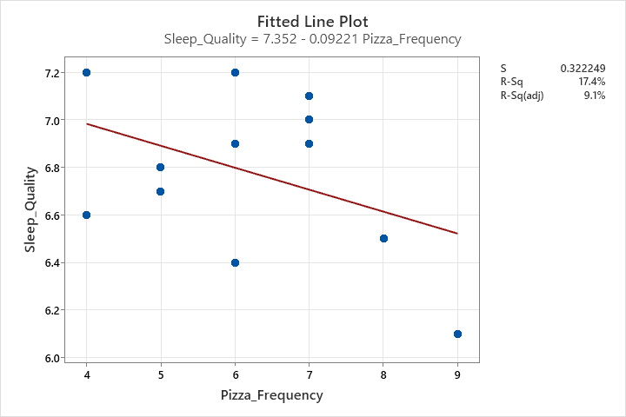
Figure 8: Pizza Frequency vs sleep quality

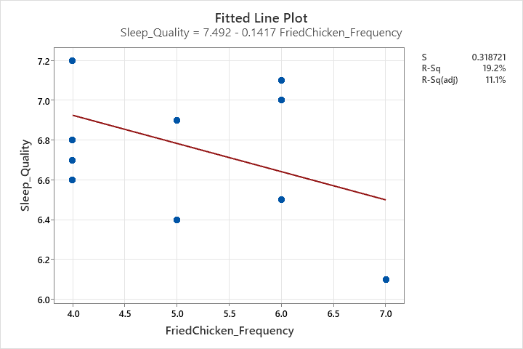
Figure 9: Fried chicken frequency vs sleep quality

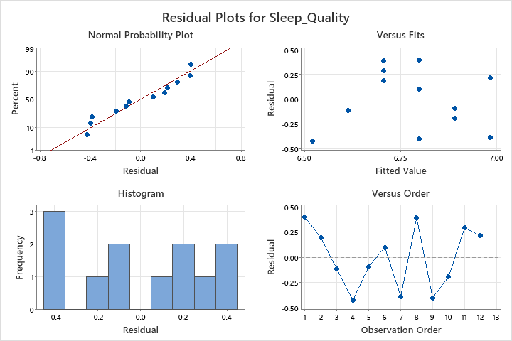
Figure 10: Residual plots for pizza frequency and sleep quality

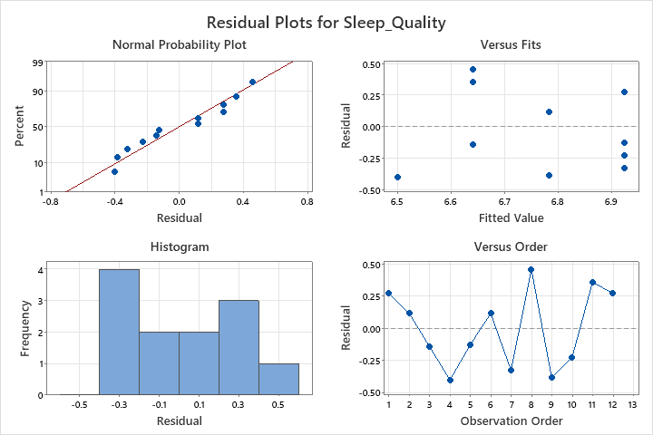
Figure 11: Residual plots for fried chicken frequency and sleep quality

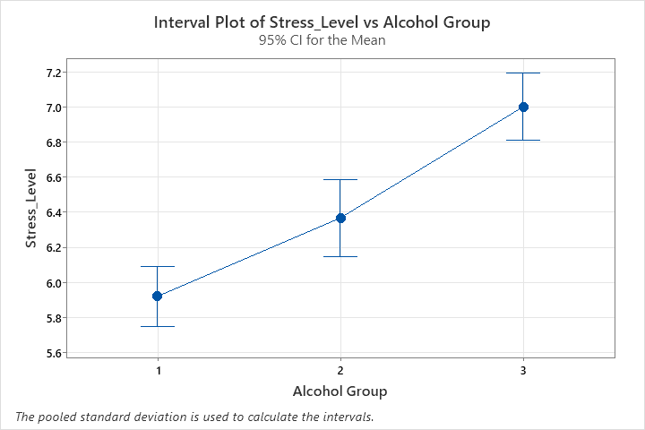
Figure 12: Stress level vs. Alcohol

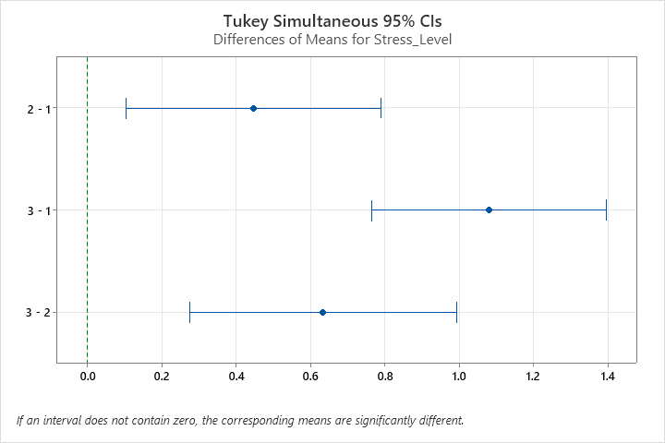
Figure 13: Turkey’s test for Stress Level versus Alcohol Group

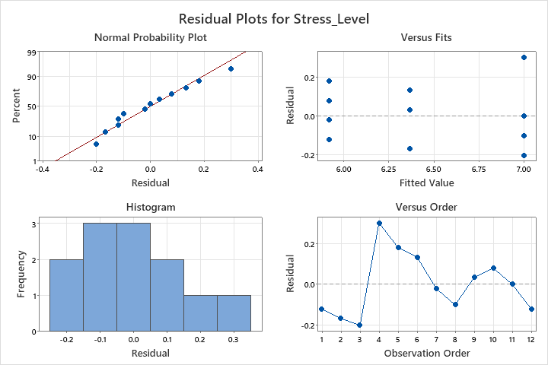
Figure 14: Residual plots of Stress Level versus Alcohol Group

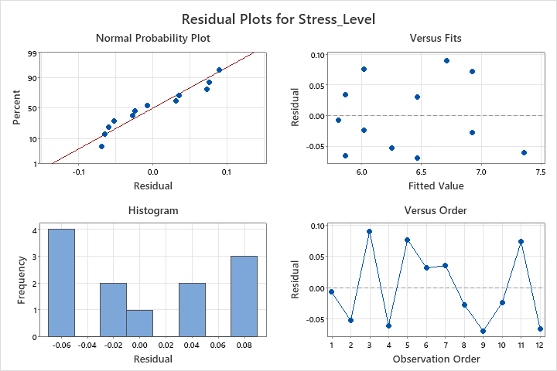
Figure 15: Residual plots of Dietary habits vs. Stress level

Bibliography
[1] Z. H. Rana, C. L. Frankenfeld, E. J. Kennedy, J. Bertoldo, L. De Jonge, and L. J. Cheskin, “Why Don’t College Freshmen Meet the US Dietary Guidelines for Added Sugar, Refined Grains, Sodium, and Saturated Fat?,” Journal of American College Health, vol. 72, no. 1, pp. 142–152, Jan. 2024,doi: https://www.gmu.edu/news/2022-02/new-study-finds-college-freshmen-exceed-many-us-dietary-guidelines-increasing-risk
[2] American College Health Association, “National College Health Assessment: Undergraduate Student Reference Group Data Report, 2025,” American College Health Association, 2025, doi : https://www.acha.org/ncha/data-results/survey-results/academic-year-2024-2025/ [Accessed: Mar. 22, 2026].

[3] A. B. Larcom, I. E. Lofgren, M. J. Delmonico, A. Missimer, and K. J. Melanson, “Ultra-processed food intake is associated with low diet quality in young adult college students,” Journal of American College Health, pp. 1–12, Dec. 2024, doi: 10.1080/07448481.2024.2404945. [Accessed: Mar. 23, 2026]
[4] B. B. Hoeppner, N. P. Barnett, K. M. Jackson, S. M. Colby, C. W. Kahler, P. M. Monti, J. Read, T. Tevyaw, M. Wood, D. Corriveau, and A. Fingeret, "Daily College Student Drinking Patterns Across the First Year of College," Journal of Studies on Alcohol and Drugs, vol. 73, no. 4, pp. 613–624, Jul. 2012, doi: https://pmc.ncbi.nlm.nih.gov/articles/PMC3364328/

